B.SARAVANAN

230701293

EXPERIMENT 7



**Experiment with different layouts and color schemes for an app. Collect user feedback on aesthetics and usability using** **GIMP(GNU Image Manipulation Program (GIMP)**

**AIM:**

The aim is to trial different app layouts and color schemes and evaluate user feedback on aesthetics and usability using GIMP.

**PROCEDURE:**

**Tool Link: https://www.gimp.org/**

**Step 1: Install GIMP**

● Download and Install: Download GIMP from GIMP Downloads and install it on your computer.

**Step 2: Create a New Project**

1. Open GIMP:

○ Launch the GIMP application.

2. Create a New Canvas:

○ Go to File -&gt; New to create a new project.

○ Set the dimensions for your app layout (e.g., 1080x1920 pixels for a

standard mobile screen). **Step 3: Design the Base Layout**

1. Create the Base Layout:

○ Use the Rectangle Select Tool to create sections for different parts of your app (e.g., header, content area, footer).

○ Fill these sections with basic colors using the Bucket Fill Tool.

Example Output: A base layout with defined sections for header, content, and footer.

2. Add UI Elements:

○ Text Elements: Use the Text Tool to add text elements like headers, buttons, and labels.

○ Interactive Elements: Use the Brush Tool or Shape Tools to draw buttons, input fields, and other interactive elements.

Example Output: A layout with labeled sections and basic UI elements.

3. Organize Layers:

○ Use layers to separate different UI elements. This allows you to easily modify or experiment with individual components.

○ Name each layer according to its content (e.g., Header, Button1, InputField).

**Step 4: Experiment with Color Schemes**

1. Create Color Variants:

○ Duplicate Layout: Duplicate the base layout by right-clicking on the image tab and selecting Duplicate.

○ Change Colors: Use the Bucket Fill Tool or Colorize Tool to change the colors of the UI elements in each duplicate.

Example Output: Multiple color variants of the same layout.

2. Save Each Variant:

○ Save each color variant as a separate file (e.g., Layout1.png, Layout2.png, etc.).

○ Go to File -> Export As and choose the file format (e.g., PNG).

**Step 5: Collect User Feedback**

1. Prepare a Feedback Form:

○ Create Form: Create a feedback form using tools like Google Forms or Microsoft Forms.

○ Include Questions: Include questions about the aesthetics and usability of each layout and color scheme.

2. Share the Variants:

○ Distribute Files: Share the image files of the different layouts and color schemes with your users.

○ Provide Instructions: Provide clear instructions on how to view each variant and how to fill out the feedback form.

3. Gather Feedback:

○ Collect responses from users regarding their preferences and suggestions.

○ Analyze the feedback to determine which layout and color scheme are most preferred.

**Step 6: Iterate and Refine**

1. Refine the Design:

○ Based on the feedback, make necessary adjustments to the layout and color scheme.

○ Experiment with additional variations if needed.

2. Final Testing:

○ Conduct a final round of testing with the refined design to ensure usability and aesthetic satisfaction.

**OUTPUT:**

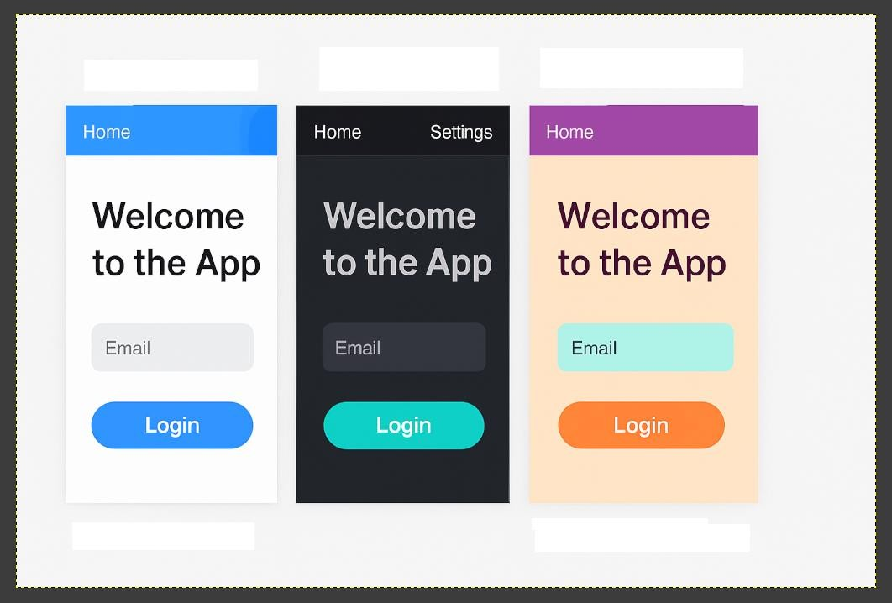

**RESULT:**

Different layouts and color schemes for an app have been experimented and user feedback on aesthetics and usability using GIMP (GNU Image Manipulation Program (GIMP) has been collected.